**Install Bitbucket Server on Linux - Offline**

**Preparation –** Before downloading and installing the Bitbucket server check if git is installed and create directory to download Bitbucket server installer

1. Make sure OS package is updated

sudo yum update -y

1. Check if Git is installed

git –version

1. If git is not installed, then run the following:

sudo yum install -y git

1. Check if wget is installed

wget –help

1. If wget is not installed, then run the following:

sudo yum install -y wget

1. Create directory to copy the bitbucket installer

sudo mkdir /opt/downloads

1. Go inside the downloads folder

cd /opt/downloads/

**Download Bitbucket Installer**

Download the latest Bibucket installer on your local machine and move the installer to Bitbucket server /opt/downloads/ directory using the WinSCP or any other tool

<https://product-downloads.atlassian.com/software/stash/downloads/atlassian-bitbucket-6.3.0-x64.bin>

**Run the Installer**

1. Once the installer is copied to **/opt/downloads/** directory, make the installer executable

$ sudo chmod +x atlassian-bitbucket-6.3.0-x64.bin

1. Run the installer

$ sudo ./atlassian-bitbucket-6.3.0-x64.bin

1. Follow the prompts to install Bitbucket

[ec2-user@ip-172-31-44-232 downloads]$ sudo ./atlassian-bitbucket-6.3.0-x64.bin

Unpacking JRE ...

Starting Installer ...

Bitbucket 6.3.0 installation wizard

Would you like to install or upgrade an instance?

**Install a new instance [1, Enter], Upgrade an existing instance [2]**

**1**

Install Bitbucket 6.3.0

What type of instance are you looking to install?

**Install a Server instance [1, Enter], Install a Data Center instance [2], Install a Smart Mirroring instance [3]**

**1**

Where should Bitbucket be installed?

**Select the folder where you would like Bitbucket 6.3.0 to be installed, then**

**click Next.**

**[/opt/atlassian/bitbucket/6.3.0]**

Default location for Bitbucket home directory

The location for Bitbucket data.

This will be the default location for repositories, plugins, and other data.

**Ensure that this location is not used by another Bitbucket installation.**

**[/var/atlassian/application-data/bitbucket]**

Configure which ports Bitbucket will use.

Configure TCP Ports

Bitbucket requires a TCP port that isn't being used by other applications.

The HTTP port is where users access Bitbucket through their browsers.

Bitbucket also requires ports 7992 and 7993 are available to run an embedded

Elasticsearch instance that provides search functionality to Bitbucket.

**HTTP Port Number**

**[7990]**

**7990**

Run as a service

For a production server we recommend that you run Bitbucket as a

Windows/Linux service because Bitbucket will restart automatically when the

computer restarts.

**Install Bitbucket as a service?**

**Yes [y, Enter], No [n]**

**y**

Please review your Bitbucket installation settings

Installation Summary

Installation Directory: /opt/atlassian/bitbucket/6.3.0

Home Directory: /var/atlassian/application-data/bitbucket

HTTP Port: 7990

Install as a service: Yes

**Install [i, Enter], Exit [e]**

**i**

Extracting files ...

Installation of Bitbucket is complete

**Would you like to launch Bitbucket?**

**Yes [y, Enter], No [n]**

**y**

Please wait a few moments while Bitbucket starts up.

Launching Bitbucket ...

Installation of Bitbucket 6.3.0 is complete

The installer was unable to detect whether Bitbucket started correctly

Please consult the '

/var/atlassian/application-data/bitbucket/log/atlassian-bitbucket.log' file

to verify that Bitbucket started successfully

Bitbucket 6.3.0 can be accessed at http://localhost:7990

**Launch Bitbucket 6.3.0 in browser?**

**Yes [y, Enter], No [n]**

**n**

Finishing installation ...

1. Once the installer completes, head to http://<hostname>:7990 in your browser to begin the setup process.

Hostname – It can be localhost if the browser is used from the same VM or EC2 Public dns name.

1. It prompts you to setup the database.

**Connect to MS SQL Database**

1. Once again, head to http://<hostname>:7990 in your browser to complete the DB setup. Provide the CPA DB details to integrate bitbucket with DB. We may come across with some hidden issues because this part we couldn’t test.

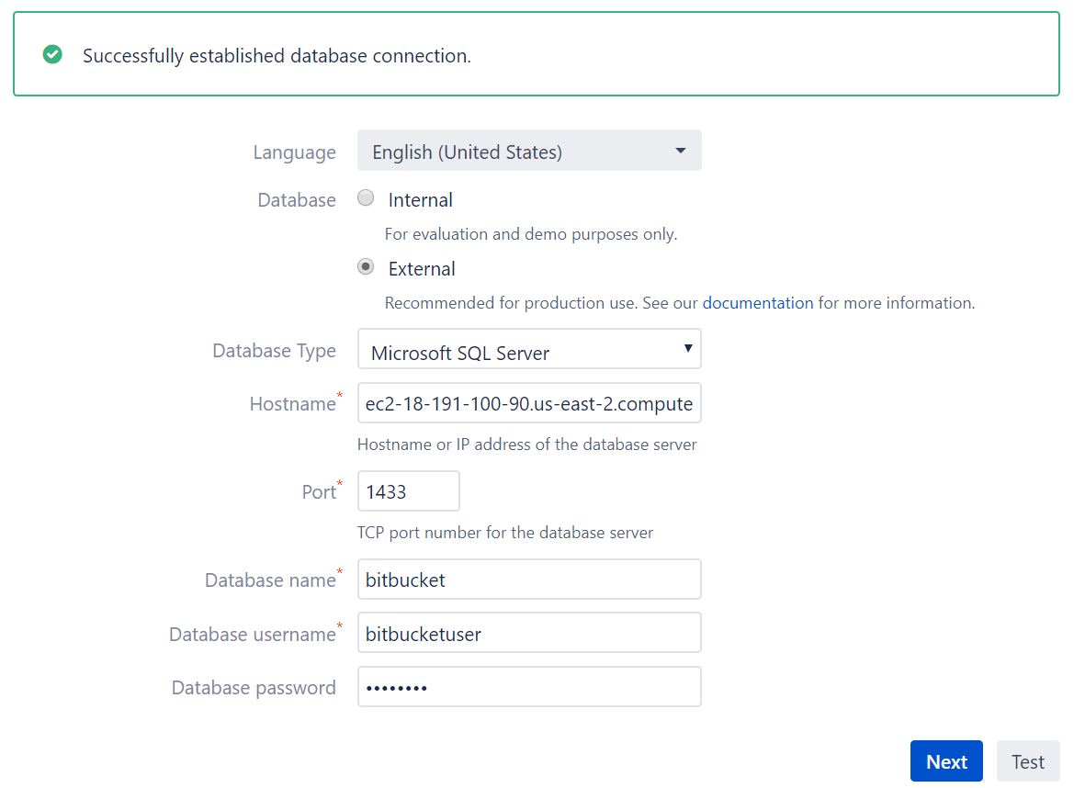

1. Click on Test and if the connection is successful then Click on Next

**Add your license key**

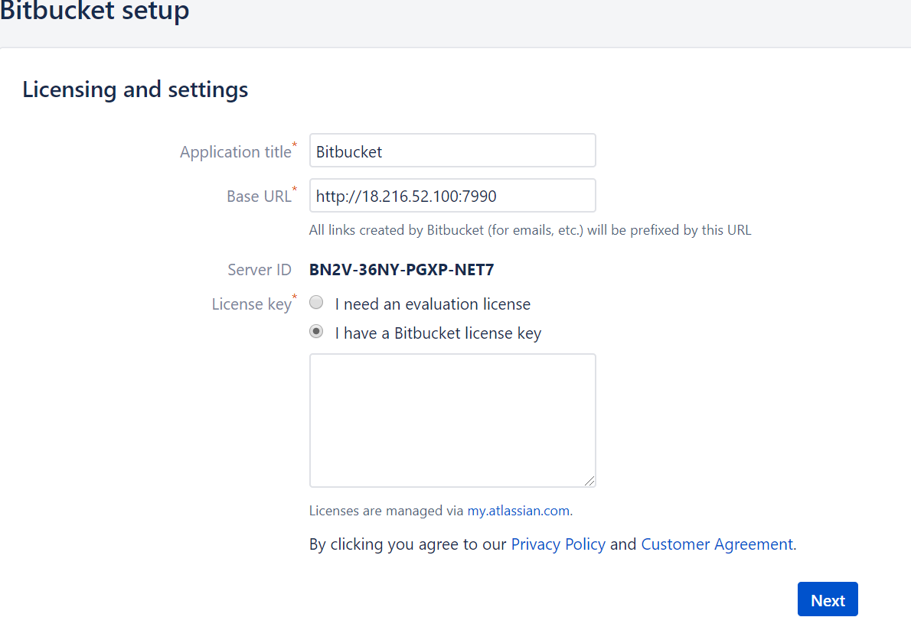

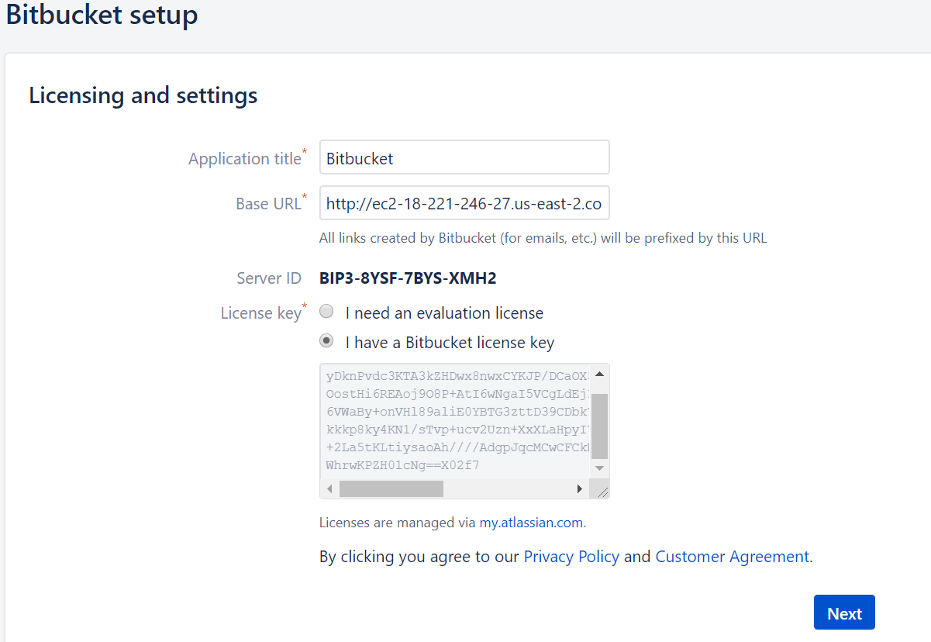

**Create your administrator account**

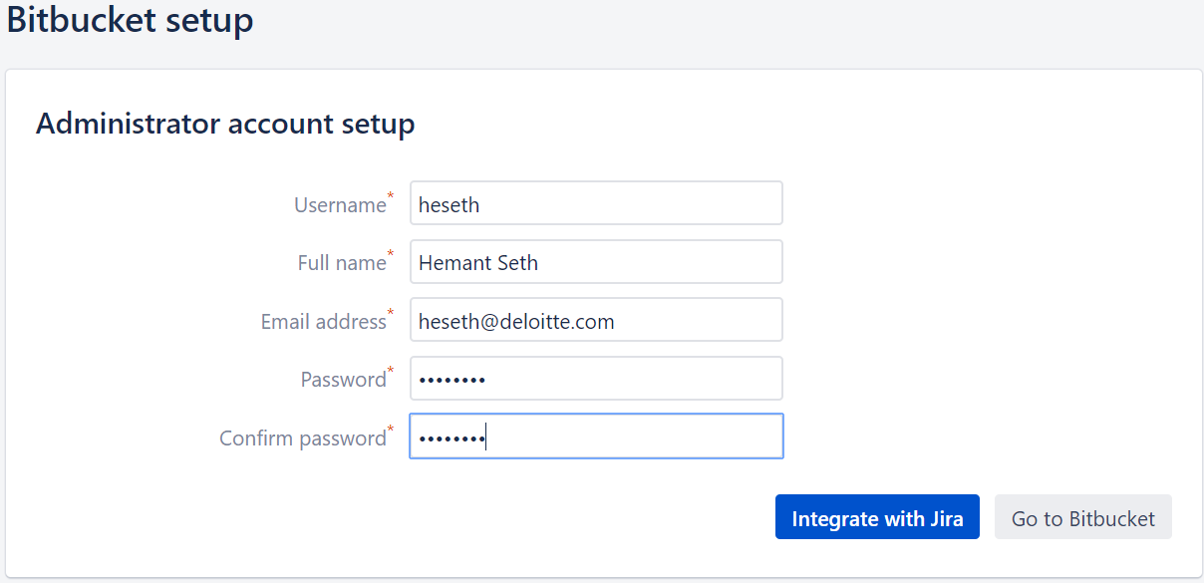

Click on Go to Bitbucket and Login

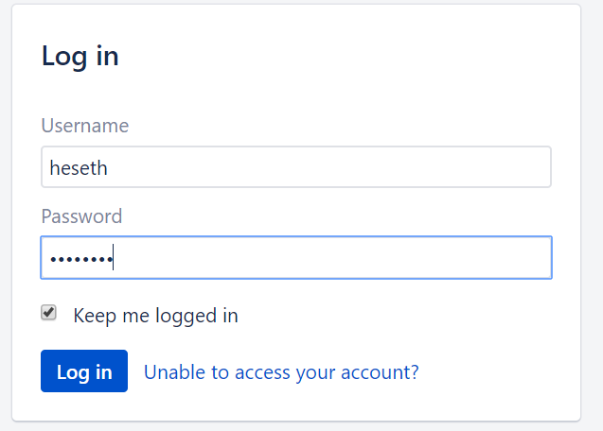

**Integrate Bitbucket with Jira**

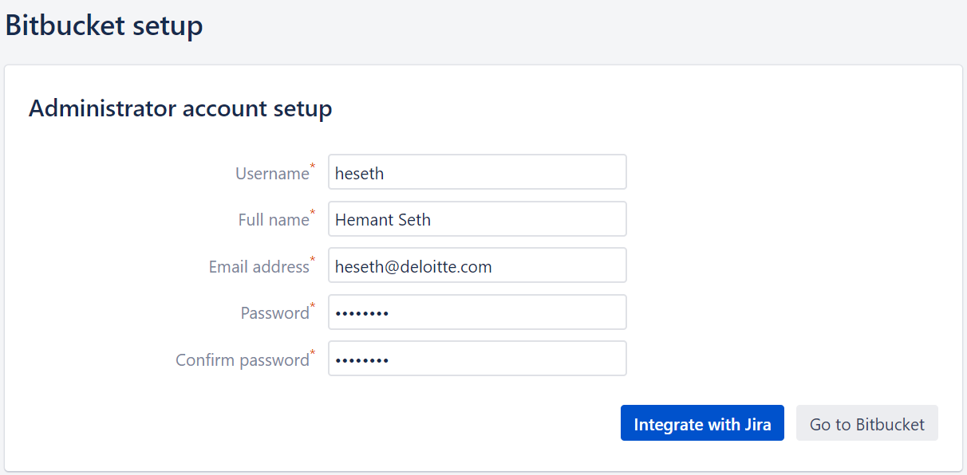

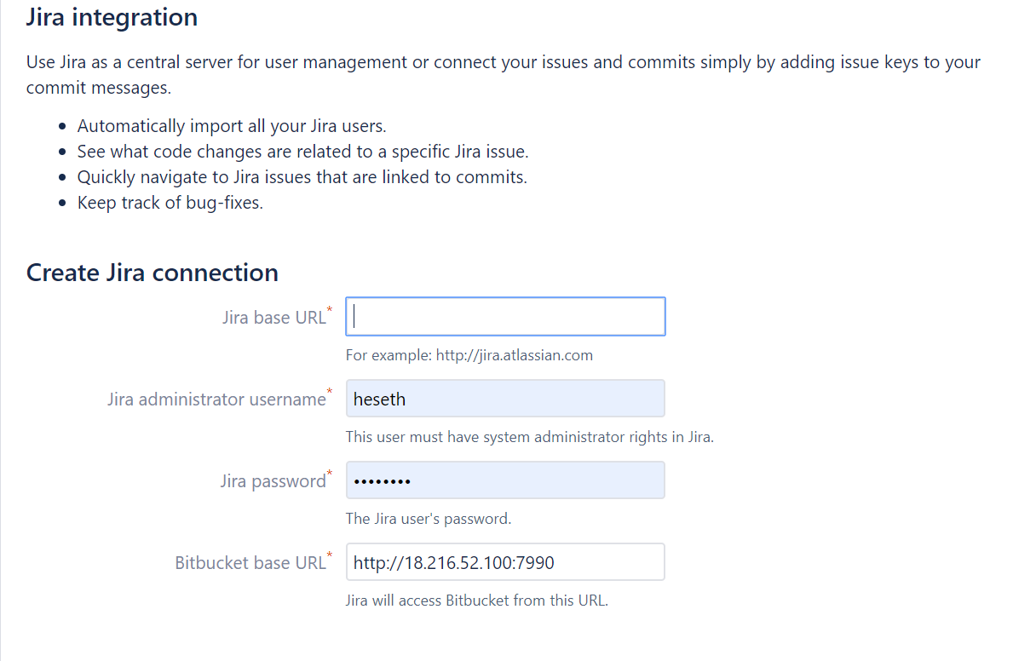

Follow the instructions in below link

<https://confluence.atlassian.com/bitbucketserver/linking-bitbucket-server-with-jira-776640408.html>

**Things to do before Production**

**Proxy and secure Bitbucket Server** - run Bitbucket Server behind a reverse proxy and enable HTTPS access.

<https://confluence.atlassian.com/bitbucketserver/proxying-and-securing-bitbucket-server-776640099.html>

**Establish a data recovery plan** - backup the home directory and database of your instance.

<https://confluence.atlassian.com/bitbucketserver/data-recovery-and-backups-776640050.html>

**Reference**

Install Bitbucket - <https://confluence.atlassian.com/bitbucketserver/install-bitbucket-server-on-linux-868976991.html>

Setup Bitbucket - <https://comtronic.com.au/how-to-install-atlassian-bitbucket-server/>

Install MS SQL - <https://computingforgeeks.com/how-to-install-microsoft-sql-server-on-rhel-centos/>

<https://docs.microsoft.com/en-us/sql/linux/quickstart-install-connect-red-hat?view=sql-server-2017>

<https://confluence.atlassian.com/bitbucketserver/connecting-bitbucket-server-to-sql-server-776640385.html>

**Troubleshooting**

https://confluence.atlassian.com/display/BitbucketServerKB/Troubleshooting+Insta llation

$ sudo yum install -y firewalld

$ sudo systemctl start firewalld

$ sudo systemctl enable firewalld

$ sudo systemctl status firewalld

$ sudo firewall-cmd --zone=public --add-port=7990/tcp --permanent

$ sudo firewall-cmd --reload

sudo systemctl stop postgresql ## <-- stop the server ##

sudo systemctl restart postgresql ## <-- resstart the server ##

sudo systemctl status postgresql ## <-- get status of the server ##

**To start/stop Bitbucket Server manually when running as service:**

# service atlbitbucket status

# service atlbitbucket stop

# service atlbitbucket start